Methodology for Medical Diagnosis based on Fuzzy Logic

Mohamed A. Madkour and Mohamed Roushdy²
Computer Science Department
Faculty of Science
King AbdulAziz University
P.O.Box. 80203 - Jeddah 21589
(1) Email: mamadkour@ kaau.edu.sa
(2) Email: mroushdy@kaau.edu.sa

Abstract
The present work introduces a simple and effective methodology for medical diagnosis based on fuzzy logic. Diagnosis of upper respiratory infections is considered here as a vehicle to illustrate the concept, yet the developed methodology is suitable for application in a much wider range of diseases. We define a set of features F relevant to the set of considered diseases D. The input case to be diagnosed is described by assigning a fuzzy value to each feature of the set F. Each disease of the set D is specified by its profile in the form of a fuzzy table obtained by consulting an expert physician. Fuzzy inference is applied to obtain a decision fuzzy set for each considered disease, and crisp decision values are obtained to state the certainty of presence for each disease. A computer program prototype is developed and used to diagnose several typical input case studies. The obtained results for all cases were excellent.

Keywords: Fuzzy Expert systems, Fuzzy medical diagnosis, Medical artificial intelligence
1. Introduction
Several methods are available to automate the process of medical diagnosis. These include classical programs that employ statistical and probabilistic methods, as well as knowledge-based systems that employ artificial intelligence techniques. Large groups at MIT and the New England Medical Center used an approach to diagnosis and treatment based on the theories of probability and utility [1]. Their aim was to build systems that gave provably optimal medical recommendations. Rule-based expert systems gained much popularity in the medical field. Feigenbaum, Buchanan and Shortliffe [2] developed MYCIN to diagnose blood infections. With about 450 rules, MYCIN was able to perform as well as some experts. Another rule-based system is used as a digital therapy advisor [3]. CASEY is a real world application that uses Cased Based Reasoning (CBR) methodology to give a diagnosis for the heart disorders [4]. In a recent work, Phan and Chen [5] describe the application of fuzzy logic to a healthcare diagnostic system in which a set of sensors monitors body temperature, blood pressure and heart rate. Many other systems are known that employ artificial intelligence techniques in the medical field and healthcare diagnostics to mention a few.

Using fuzzy logic in medical diagnosis is a promising technique that can easily capture the required medical knowledge and come up with sound diagnosis decisions. Practically, an expert physician tends usually to specify his experience in rather fuzzy terms, which is more natural to him than trying to cast his knowledge in rigid rules having abrupt premises.
The present work introduces a simple and effective methodology to develop fuzzy expert systems for medical diagnosis. The methodology is general and can be used in diagnosing a wide range of diseases. However to illustrate the concept we consider in this paper a set of eight upper respiratory infections to develop a prototype computer program that can infer proper diagnosis decisions based on patient data.
The paper is structured as follows. Fuzzy medical diagnosis is discussed in section 2. Section 3 introduces the developed fuzzy logic methodology for medical diagnosis. Experimental results for a typical patient case are given in Section 4. Concluding remarks and suggestions for future work are provided in section 5.

2. Fuzzy Medical Diagnosis
Medical artificial intelligence is primarily concerned with the construction of AI programs that perform diagnosis and make therapy recommendations. Unlike medical applications based on another programming method such as purely statistical and probabilistic methods, medical AI programs are based on symbolic models of disease entities and their relationship to patient factors and clinical manifestations [6]. Medical expert systems contain medical knowledge, usually about a very specifically defined task, and are able to reason with data from individual patients to come up with reasoned conclusions. Fuzzy logic is a superset of conventional (Boolean) logic that has been extended to handle the concept of partial truth – truth values between "completely true" and "completely false". It was introduced by Zadeh in 1965 [7] as a means to model the uncertainty of natural language.
In this paper we develop a fuzzy expert system that uses a collection of fuzzy membership functions and rules, instead of Boolean logic, to reason about data. Leung, Lau and Kwong [8] describe a general structure of a fuzzy system to be used as the core part of a fuzzy application. The structure can be summarized in the following four steps, carried out in order:
(1) Fuzzification: the membership functions defined on the input variables are applied to their actual values, to determine the degree of truth for each rule premise. (2) Inference: the truth value for the premise of each rule is computed, and applied to the conclusion part of each rule. This result in one fuzzy subset to be assigned to each output variable for each rule.
(3) Composition: all of the fuzzy subsets assigned to each output variable are combined together to form a single fuzzy subset for each output variable.
(4) Deffuzification: is an optional step which is used when it is useful to convert the fuzzy output set to a crisp number.
Many defuzzification methods are available [9], however two of the more common techniques are the CENTROID (center of area) and the MAXIMUM methods. In the CENTROID method, the crisp value of the output variable is computed by finding the variable value of the center of gravity of the membership function for the fuzzy value. In the MAXIMUM method, one of the variable values at which the fuzzy subset has its maximum truth value is chosen as the crisp value for the output variable.
The developed fuzzy expert system prototype would query the user for the relevant patient symptoms. The strength of each single symptom is specified by a fuzzy value such as low, moderate, and high for those symptoms that cannot be measured quantitatively. Other measurable symptoms such as the temperature or blood sugar for instance would be input directly as numeric values that would be properly fuzzified. The prototype proceeds through the above-mentioned inference process and provides a percent value for the certainty of presence for each one of the considered eight diseases.

3. Methodology
Medical diagnosis usually involves careful examination of a patient to check the presence and strength of some features relevant to a suspected disease in order to take a decision whether the patient suffers from that disease or not. A feature, like a runny nose for instance, may appear to be very strong for one patient but it can be moderate or even very light for another. It is the experience of the physician that tells him how to combine a set of symptoms (features and their strengths) to find out the correct diagnostic decision.
In the present work, we aim to capture the physician’s experience and store it in a set of fuzzy tables. Fuzzy inference is employed to develop a computer program that can automatically find out the certainty whether a patient having some specified symptoms suffers from any one of a set of suspected diseases. This certainty is specified as a crisp percentage value for every suspected disease.
We consider a set of m diseases D, and define a collective set of n features F relevant to these diseases. Usually we have n>>m. Let:
D = {d₁ , d₂ , d₃ , … , d_{m} }
F = { f₁ , f₂ , f₃ , … , f_{n} }
To specify the symptoms of a patient, he would be checked against all features in the set F and a fuzzy value would be assigned to each feature. The fuzzy values are selected from the set:
{ Very Low, Low, Moderate, High, Very High }
For example, a single symptom can be specified as < runny nose, Moderate >. By checking the patient for all n features of the set F and assigning a proper fuzzy value for each feature, the set of patient’s symptoms S will be obtained as follows:
S = { <f₁ , v₁> , <f₂ , v₂> , <f₃ , v₃> , … , <f_{n} , v_{n}> }
where: v_{i} is the fuzzy value assigned to the feature f_{i} when checking the patient, i=1, … ,n.

3.1 Fuzzy Knowledge Representation
The experience of the expert physician regarding the set of considered diseases D is captured in a set of fuzzy tables, each of which specifies the profile for one disease. We consider three fuzzy sets Yes, May Be, and No as shown in fig.1 to represent the certainty of disease presence. Entries in the disease profile tables would be selected from these fuzzy sets.
No MayBe Yes
0
0.2
0.4
0.6
0.8
1
0
20
40
60
80
100
Certainty Level
Truth value
Fig.1 Fuzzy sets for the certainty of disease presence.
For a given disease there will be a set R of k ≤ n relevant features which is a subset of the collective features set F. Table 1 shows an empty fuzzy table for the disease profile. It shows five fuzzy values for each relevant feature r_{i} , i=1, … , k.
Table 1. Fuzzy table for the disease profile.
Relevant Features | Fuzzy Value of the Symptom
Relevant Features | Very Low | Low | Moderate | High | Very Hgh
r₁
r₂
r₃
…
r_{k}
It is the responsibility of the expert physician to suggest suitable values for each and every entry in the disease profile table based on his experience. This should be done for every disease in the set of considered diseases D. Table 2 shows the profile tables for two of the considered upper respiratory infections based on an expert physician consultation. Similar profile tables are also obtained for the rest of the considered diseases.

Table 2.a. Profile for the Flu
Attributes  Features | Very Low | Low | Moderate | High | Very High
Runny nose | No | No | May be | Yes | Yes
Fever | No | May be | Yes | Yes | Yes
Cough | No | May be | Yes | Yes | Yes
Body aches strong | No | May be | Yes | Yes | Yes
Headache | No | May be | Yes | Yes | Yes
Conjunctivitis | No | No | May be | Yes | Yes
Swollen lymph nodes in neck | No | No | May be | May be | May be
Weakness in body | No | No | May be | Yes | Yes
Vomiting | No | No | Yes | May be | May be
Sore throat | No | No | Yes | Yes | Yes
Loss of appetite | No | Maybe | Yes | Yes | Yes
Sneezing | Maybe | Maybe | Yes | Yes | Yes

Table 2.b. Profile for the Common Cold
Attributes  Features | Very Low | Low | Moderate | High | Very High
Runny nose | No | No | May be | Yes | Yes
Fever | No | May be | May be | No | No
Cough | No | May be | May be | May be | May be
Body aches strong | No | No | May be | No | No
Headache | No | No | May be | No | No
Weakness in body | No | No | No | May be | May be
Sore throat | No | May be | May be | Yes | Yes
Loss of appetite | No | May be | May be | No | No
Sneezing | No | No | May be | Yes | Yes

3.2 Fuzzy Inference
Upon examining the patient to be diagnosed, the set of his symptoms S would be obtained. A typical example for the set of symptoms is given in table 3 which shows fuzzy values for all features in the collective set F. It is completely natural to specify the strength of a non-measurable feature by a fuzzy value. However, there are other measurable features such as the temperature, pressure, and blood sugar, etc. that can be specified by numbers. The next subsection shows how to fuzzify such features.
Table 3. Typical symptoms for a given input case.
Features | Fuzzy Value* |  | Features | Fuzzy Value*
Runny nose | M |  | Swollen lymph nodes behind ear | VL
Rash Light rosy color | VL |  | Opitrocheolor L.N. enlargement | VL
Rash Brownish pink | VL |  | Can’t suck on lemon | VL
Rash Spotty blisters & pimples | VL |  | Salivary glands swollen | VL
Rash Purplish or reddish spots | VL |  | Saliva is not normal | VL
Fever | H |  | Swollen lymph nodes in neck | M
Cough | M |  | Weakness in body | H
Harsh & Hacking cough | VL |  | Vomiting | M
Whooping cough | VL |  | Diarrhea | VL
Body aches strong | L |  | Sore throat | M
Headache | L |  | Itching | VL
Intolerance to light | VL |  | Loss of appetite | L
Bloodshot eyes | VL |  | Sneezing | M
Conjunctivitis | H |  | Convulsion | VL
White spots inside cheek | VL |  | Centralcynosis | VL
Joints pain | VL
* VH=very high, H=high, M=moderate, L=low, and VL=very low.
Let:
s[f] = fuzzy value for the feature f of the input case’s symptoms.
r_{ij} = j^{th} relevant feature of the i^{th} disease.
P_{ij} [r_{ij} , v] = certainty of presence of the i^{th} disease when the relevant feature r_{ij} has a fuzzy value v.
δ_{ij} = diagnosis decision of the i^{th} disease based on the relevant feature r_{ij} .
k_{i} = total number of relevant features for the i^{th} disease.
w_{ij} = weight of the r_{ij} feature in diagnosing the i^{th} disease.
σ_{i} = overall diagnosis decision for the i^{th} disease.
The effect of the r_{ij} feature on the diagnosis decision can be directly obtained from the disease profile table P_{ij} [r_{ij} , v]. The fuzzy value v is obtained from the patient’s symptoms for the feature r_{ij} as s[r_{ij}]. This effect δ_{ij} would be one of the fuzzy sets Yes, May Be, and No. It can be represented as follows:
δ_{ij} = P_{ij} [r_{ij} , s[r_{ij}]] (1)
By summing up the effect of all k_{i} relevant features, the overall diagnosis decision for the i^{th} disease would be obtained as follows:
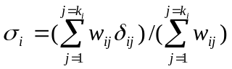 (2)

The weighting factor w_{ij} is introduced here to allow the physician to specify that some features can have more or less significance than others when diagnosing a disease, and he should set proper relative values to the weights. If he considers that all features have the same significance, then the weighting factor will be unity for all features. In this case equation (2) can be simplified to be:

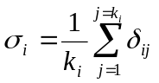 (3)

The final step is to obtain crisp values specifying the certainty of presence for every disease in the set D. To show how to obtain such crisp values, consider the following example.
- Assume that a given disease d_{i} has 10 relevant features, all of which has the same weight in the diagnosis. That is:
k_{i} = 10,
w_{ij} = 1 for all j = 1, … , 10.
- Assume that when using equation (1) to find out the diagnostic decisions ( δ_{ij} , j = 1, … , 10 ) the result was 7 Yes, 2 May Be, and 1 No.
- The overall diagnostic decision will be:
σ_{i} = ( 7 Yes + 2 May Be + 1 No ) / 10
This fuzzy set will be as shown in fig.2.
- The center of area method is considered for defuzzification. Let:
c_{i} = centroid of the overall diagnosis decision fuzzy set
c_{y} = centroid for the Yes fuzzy set
q_{i} = certainty of presence of the considered disease d_{i} in percent
Consequently, the crisp decision value for the disease d_{i} will be computed as shown below. It should be noted that if the results were Yes for all relevant features of d_{i}, the decision would be 100%.
q_{i} = (c_{i} / c_{y} ) x 100% (4)
- For the present example, the values of c_{i} and c_{y} are 0.69 and 0.87, respectively. This tells that the certainty of presence of the considered disease is 79% as shown in Fig.2.

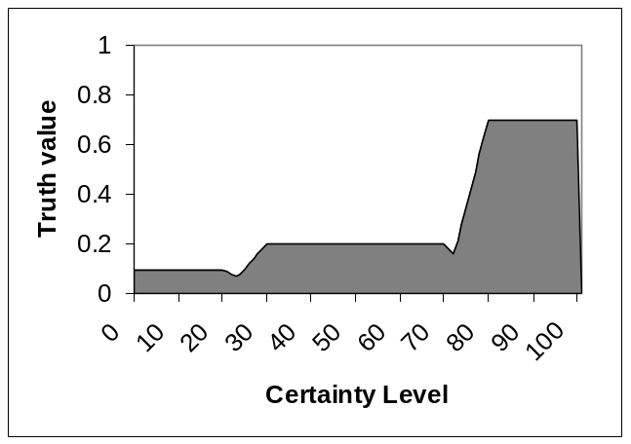
c_{i} = 0.69 c_{y} = 0.87 q_{i} = 79 %
Fig.2 Fuzzy set representing the overall diagnosis decision for the example case.

  - Handling Measurable Features
The symptoms for measurable features such as temperature, blood suger, etc. will be specified as a numeric value. For simplicity one may use fixed tables prepared by the physician to map these numeric values into fuzzy values from the set { Very Low, Low, Moderate, High, Very High }. This solution may be adequate in some cases. However, we show next a better solution that is more accurate and avoids abrupt changes. We consider here the blood suger for illustration.
Fig.3 shows four fuzzy sets that map percentage values of Glycosylated HB (stored sugar). If the measured value is 8.7% for instance, this will belong to the Medium fuzzy set with a membership value of 0.3, and to the High fuzzy set with a membership value of 0.7.
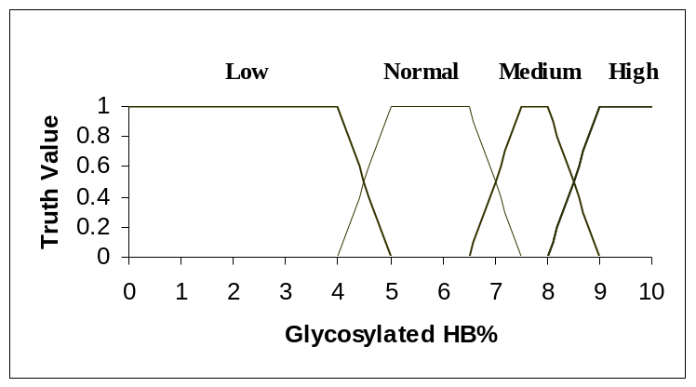
Fig.3 Fuzzy sets for the Glycosylated HB% values.
Assume that the following information is stored in the profile table of some disease d_{i}.
If the Glycosylated HB is Medium then the certainty of presence of d_{i} is May Be.
If the Glycosylated HB is High then the certainty of presence of d_{i} is Yes.
Therefore, the diagnosis decision δ_{ij} for the disease d_{i} based on the Glycosylated HB value of 8.7% will be the upper envelop of two fuzzy sets: 0.3 May Be , and 0.7 Yes as shown in fig.4. This will be included in equation (2) to provide the overall decision.
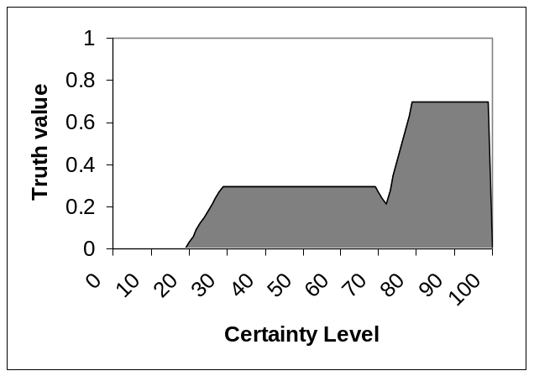
Fig.4 Fuzzy set of the diagnosis decision for a Glycosylated HB of 8.7%.
The above solution can be generalized to include features that are specified by two numeric values such as the blood pressure. In this case a given measurement may result in four possible fuzzy sets, and the minimum rule [9] should be applied to combine pairs of fuzzy sets by the AND operator.
4. Sample Results
We present in this study the diagnosis decisions obtained by the developed prototype fuzzy expert system using a typical case study. The prototype system checks for 8 suspected upper respiratory infections and considers a total of 31 features. The input symptoms shown in Table 3 are used in this case study. The symptoms are obtained by physically checking a patient and manually feeding the input to the prototype program. Table 4 presents the obtained diagnosis decisions for all suspected diseases, and Fig. 5 shows the output fuzzy sets for the overall diagnosis of two diseases having some common symptoms (refer to table 2).
Table 4. Obtained diagnosis decisions for the case study
Disease | Common Measles | German Measles | Mumps | Flu | Chicken Pox | Whooping Cough | Common Cold | Meningitis
Certainty Level % | 0.530 | 0.430 | 0.615 | 0.734 | 0.571 | 0.642 | 0.225 | 0.262
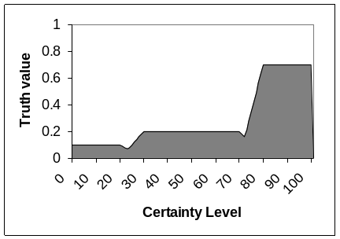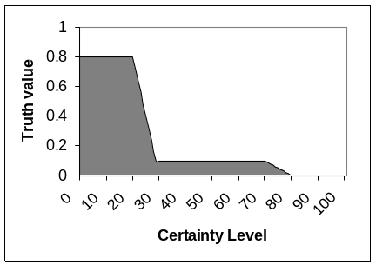
(a) Flu (b) Common Cold
Fig.5 Output fuzzy sets for the diagnosis decision of two infections

According to the input symptoms, the prototype expert system has given a high certainty level of 73.4% for the Flu, and lower levels for all other suspected infections. That result agrees completely with the diagnosis of human expert physicians. It should be noted that the proper selection of the membership functions for the three fyzzy sets Yes, MayBe, and No helps to improve the final results. In the present work, we used the shapes shown in Fig.1 and experimented with different parameter values to increase the output certainty level of the most possible disease and decrease that of all others.

5. Conclusion
Fuzzy logic is a simple and effective technique that can be advantageously used for medical diagnosis of a wide range of diseases. We present in this study a methodology to capture the experience of expert physicians and store it in fuzzy tables to represent disease profiles. Simple fuzzy inference techniques can be used to provide sound diagnosis decisions. A case study is provided to illustrate the quality of obtained results for a typical input case. Complete agreement with the diagnosis of human expert physicians has been obtained in many experiments with different input symptoms in each case study.
The developed system may be enhanced to reduce the effort of initial physical checking and manual feeding of the input symptoms. It is highly appreciated to develop on online front end in which sensors and measuring instruments are used to collect as much as possible of the required patient data and feed it automatically to the fuzzy expert system.

References
[1] Russell, S. and Norvig, P., Artificial Intelligence: A modern approach, pp. 23, Prentice-Hall International, 1995.
[2] Buchanan, B. and Shortliffe, E., Rule-Based Expert Systems, Addison-Wesley, Reading, Massachusetts, 1984.
[3] Waterman, D.A., A Guide to Expert Systems, Reading, MA: Addison-Wisley, 1986.
[4] Kolodner, J. L., Case-Based Reasoning, California: Morgan Kaufman Publishers, 1993.
[5] Phan, T. and G. Chen, Some Applications of fuzzy Logic in Rule-Based Expert Systems, Expert Systems, vol.19, No.4, pp.208-223, 2002.
[6] Clancey, W. J. and Shortliffe, E. H. (ed.)., NEOMYCIN: Reconfiguring a rule-based expert system for application to teaching. In: Readings in Medical Artificial Intelligence: The First Decade, Addison-Wesley, pp.361-381, 1984.
[7] Zadeh, L. A., Fuzzy sets, Information and Control, 8, pp.338-353, 1965.
[8] Leung R.W.K, Lau H.C.W., and Kwong C.K., On a responsive replenishment system: a fuzzy logic approach, Expert Systems, vol. 20, pp. 20-32, 2003.
[9] Klir, J.K. and Yuan, B., Fuzzy Sets and Fuzzy Logic: Theory and applications, Prentice-Hall, 1995.

¹ On leave from the Systems and Computers Dept., Faculty of Engineering, Al-Azher University, Cairo, Egypt. ² On leave from Computer Science Dept., Faculty of Computer and Information Sciences, Ain Shams University, Cairo, Egypt.

